Experiment-2
Feedforward Neural Network (MLP)

1. Aim
To understand the architecture and training process of a Multilayer Perceptron (MLP) for tabular data by implementing it on the Iris dataset, with detailed visualization of forward propagation, backpropagation, and hidden-layer activations for selected samples.

2. Theory
Introduction to Feedforward Neural Networks
A Multilayer Perceptron (MLP) is a class of deep learning model within feedforward neural networks, designed to learn a mapping between input data and corresponding output targets, expressed as
$$\hat{y}=f(x;θ),$$
where $x$represents the input features, $\hat{y }$denotes the predicted output, and $θ$comprises the model parameters, including weights and biases. In classification tasks, the model assigns inputs to discrete classes, while in regression it predicts continuous values. A feedforward network is characterised by the unidirectional flow of information from the input layer through one or more hidden layers to the output layer, without any feedback connections, making it suitable for standard prediction tasks.The objective of such networks is to approximate an underlying target function $f^{*}$. For instance, in a classification task, the network learns a mapping
$$y=f^{*}(x),$$in classification problems. A layered feedforward network ensures that all paths from input to output pass through the same number of layers, and it is considered fully connected when each neuron in one layer is linked to every neuron in the next. The key strength of MLPs lies in their ability to model complex, non-linear relationships and to generalise effectively to unseen data when trained on representative datasets.
Architecture of MLP
An MLP consists of multiple layers arranged sequentially:
- Input layer: accepts raw input features.
- Hidden layers: perform intermediate transformations.
- Output layer: produces the final prediction.
Each neuron in a layer is connected to every neuron in the next layer, forming a fully connected network. A network is called a layered feedforward network if every path from input to output passes through the same number of layers. Hidden layers are responsible for learning useful intermediate representations from the data.
Up to now, neural networks have been described as models in which the output of one layer is used as the input to the next layer; such architectures are called feedforward neural networks. In a pure feedforward network, information is always fed forward, never fed back, so there are no recurrent feedback loops. This can also be shown in Figure 1.
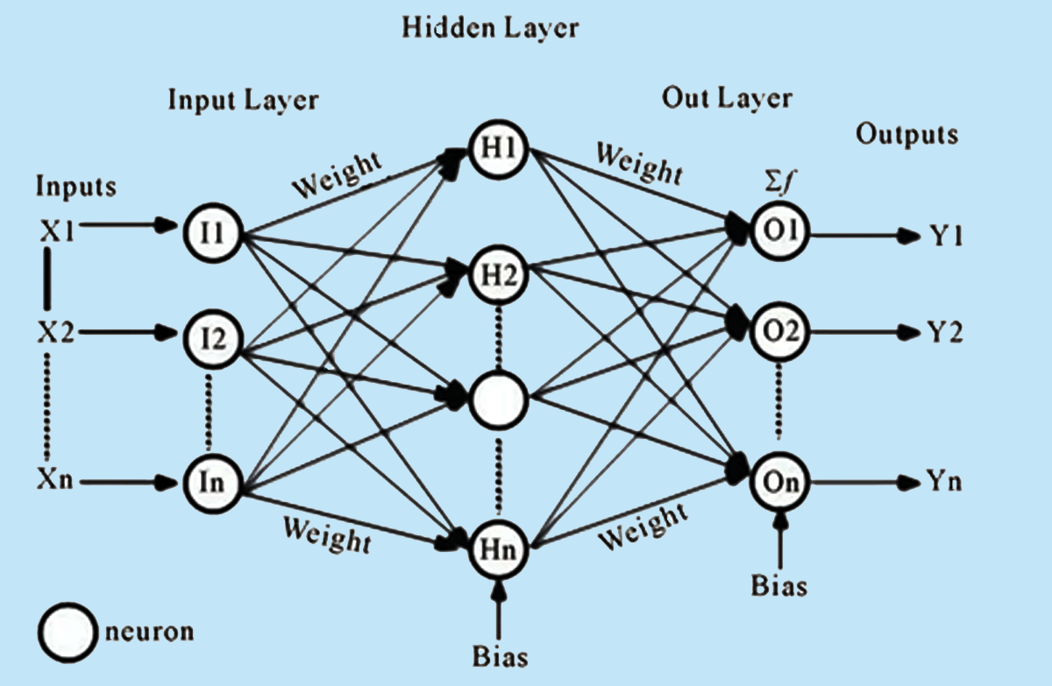
Figure 1 – Feed-Forward Neural Network Architecture
(Source: Based on the standard multilayer perceptron model as presented in Goodfellow, Bengio & Courville, Deep Learning, MIT Press, 2016)

Mathematical Representation of MLP
Let the network consist of $L$layers. The computation at each layer is performed in two steps.
Step 1: Linear Transformation
$$z^{\left(l\right)}=W^{\left(l\right)}h^{\left(l − 1\right)}+b^{\left(l\right)}$$
Step 2: Non-linear Activation
$$h^{\left(l\right)}=ρ\left(z^{\left(l\right)}\right)$$
where:
- $W^{\left(l\right)}$is the weight matrix of layer $l$,
- $b^{\left(l\right)}$is the bias vector,
- $ρ(⋅)$is the activation function such as ReLU, sigmoid, or tanh,
- $h^{\left(l\right)}$is the output of layer $l$,
- $h^{\left(0\right)}=x$, the input vector.
The overall network is a composition of such transformations:
$$Φ(x)=W_{L}ρ \left(W_{L-1}ρ (⋯ρ(W1​x+b1​)⋯) + b_{L-1}\right)+b_{L}$$
This formulation shows that an MLP is built by stacking linear and non-linear transformations layer by layer.
Forward Propagation
Forward propagation is the process of passing input data through the network layer by layer. The input $x$is transformed using weights, biases, and activation functions until the final output $\hat{y}$is produced. In a feedforward neural network, information flows forward from the input to the output, and this process defines how predictions are generated.
For a typical MLP, the layer-wise computation can be written as:
$$h_{1}=ρ(W_{1}x+b_{1}) \\ h_{2}=ρ(W_{2}h_{1}+b_{2}) \\ \hat{y}=g(W_{L}h_{L-1}+b_{L})$$
where $g(⋅)$denotes the output activation function. In a classification task, $g(⋅)$is usually softmax. The forward pass is also the stage at which the prediction is produced before the loss is computed.
Loss Function (Error Measurement)
To evaluate how well the model performs, a loss function is used. It measures the difference between the predicted output $\hat{y}$and the actual output $y$. The goal of training is to minimise this loss function so that predictions become closer to the true targets.
For regression problems, the least-squares loss is commonly used:
$$J(θ)=\frac{1}{2}∥y-\hat{y}∥^{2}$$
For classification problems, cross-entropy loss is used. Since the Iris dataset in this experiment is a multi-class classification problem, categorical cross-entropy is appropriate:
$$J(θ)=-\sum_{i=1}^{C}{y_{i}}log⁡({\hat{y}}_{i})$$
where:
- $y_{i}$is the true one-hot encoded label,
- ${\hat{y}}_{i}$is the predicted probability for class $i$,
- $C$is the number of classes,
- $θ$represents all model parameters.
This loss function quantifies how far the predicted probability distribution is from the true class distribution.
Backpropagation (Learning Mechanism)
Backpropagation is the core algorithm used to train an MLP. It computes how the loss changes with respect to each parameter in the network. More precisely, the objective is to compute gradients of the cost function $J(θ)$with respect to the weights and biases. This is done using the chain rule of differentiation.
The gradients computed during backpropagation include:
$$\frac{∂J(θ)}{∂W^{\left(l\right)}},\frac{∂J(θ)}{∂b^{\left(l\right)}}$$
The process can be described as follows:
- Compute the error at the output layer.
- Propagate the error backward through the hidden layers.
- Compute the gradient of the loss with respect to each parameter.
These gradients are then used to update the model parameters during training.
Parameter Update (Optimisation)
Once gradients are computed, the parameters are updated using gradient descent:
$$θ←θ-η\frac{∂J(θ)}{∂θ}$$
where $η$is the learning rate. This update rule moves the parameters in the direction that reduces the loss function.
Common optimisers include:
- Stochastic Gradient Descent (SGD)
- RMSprop
- Adam
These optimisation methods differ in how they scale or adapt the updates, but they all aim to minimise the same cost function $J(θ)$.
Optimisation Algorithms
Common optimisation algorithms used for training neural networks include Stochastic Gradient Descent (SGD), RMSprop, and Adam. These methods aim to minimise the cost function $J(θ)$by iteratively updating the model parameters $θ$. Although all three algorithms optimise the same objective function, they differ in how they compute and scale parameter updates, which affects convergence speed and stability.
Stochastic Gradient Descent (SGD)
Stochastic Gradient Descent (SGD) is one of the simplest and most widely used optimisation techniques. It updates the model parameters using the gradient of the loss function computed over a mini-batch of training samples. The update rule is given by
$$θ_{t+1}=θ_{t}-η∇_{θ}J(θ_{t}),$$
where $η$is the learning rate and $∇_{θ}J(θ_{t})$represents the gradient of the cost function with respect to the parameters at iteration $t$. Although SGD is computationally efficient, it may converge slowly and can exhibit oscillations, particularly in regions where the loss surface is highly curved.

RMSprop
RMSprop is an adaptive learning rate method that improves upon SGD by scaling the parameter updates based on the magnitude of recent gradients. It maintains an exponentially weighted moving average of the squared gradients, defined as
$$v_{t}=βv_{t-1}+(1-β){\left(∇_{θ}J(θ_{t})\right)}^{2},$$
where $β$is the decay rate. The parameter update rule is then given by
$$θ_{t+1}=θ_{t}-\frac{η}{\sqrt{v_{t}}+ϵ}∇_{θ}J(θ_{t}),$$
where $ϵ$is a small constant added to ensure numerical stability. By normalising the gradient, RMSprop helps stabilise the learning process and is particularly effective when dealing with non-stationary objectives.

Adam (Adaptive Moment Estimation)
Adam is an advanced optimisation algorithm that combines the benefits of momentum and adaptive learning rates. It computes both the first moment and the second moment of the gradients. The moment estimates are given by
$$m_{t}=β_{1}m_{t-1}+(1-β_{1})∇_{θ}J(θ_{t}), \\ v_{t}=β_{2}v_{t-1}+(1-β_{2}){\left(∇_{θ}J(θ_{t})\right)}^{2},$$
where $β_{1}$and $β_{2}$are decay rates. These estimates are bias-corrected as follows:
$${\hat{m}}_{t}=\frac{m_{t}}{1-β_{1}^{t}},{\hat{v}}_{t}=\frac{v_{t}}{1-β_{2}^{t}}.$$
The parameter update rule is then given by
$$θ_{t+1}=θ_{t}-\frac{η}{\sqrt{{\hat{v}}_{t}}+ϵ}{\hat{m}}_{t}.$$
Adam is widely used due to its efficiency, robustness, and ability to converge quickly in practice.

Training Workflow
The entire training process consists of repeating the following steps:
- Forward propagation to compute predictions.
- Loss computation to measure prediction error.
- Backpropagation to compute gradients.
- Parameter update using an optimisation algorithm.
This cycle is repeated for multiple epochs until the model converges or reaches a predefined stopping condition.

These models are called feedforward because information flows through the function being evaluated from $x$, through the intermediate computations used to define $f$, and finally to the output $\hat{y}$. There are no feedback connections in which the outputs of the model are fed back into itself.
- Gradient-Based Learning: For feedforward neural networks, it is important to initialise all weights to small random values; biases may be initialised to zero or to small positive values. Iterative gradient-based optimisation algorithms, such as SGD, RMSProp, and Adam, are used to train feedforward networks and deep models.
- Learning XOR: To illustrate the capabilities of feedforward networks, consider the XOR function. XOR returns 1 when exactly one of $x_{1}$or $x_{2}$is 1, and 0 otherwise. Learning XOR demonstrates that an MLP with a hidden layer can represent non-linearly separable functions.
To make the idea of a feedforward network more concrete, we begin with an example of a fully functioning feedforward network on a very simple task: learning the XOR function. The XOR function (“exclusive or”) is an operation on two binary values, $x_{1}$and $x_{2}$. When exactly one of these binary values is equal to 1, the XOR function returns 1. Otherwise, it returns 0. The XOR function provides the target function $y=f^{*}\left(x\right)$that we want to learn. Our model provides a function $y=f(x;θ)$, and our learning algorithm adapts the parameters $θ$to make $f$as similar as possible to $f^{*}$.

The process of forward propagation from input to output and backward propagation of errors is repeated several times until the error gets below a predefined threshold. The whole process is represented in the following diagram:
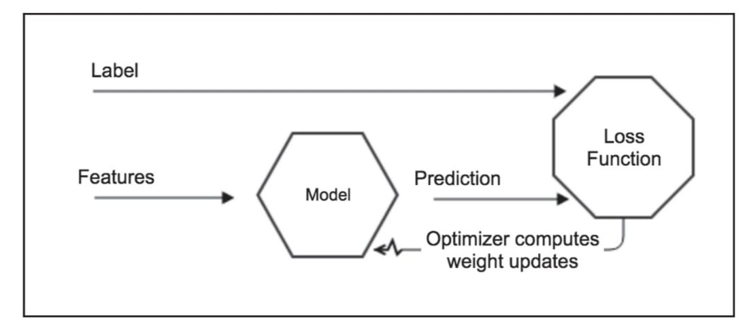
Figure 2- MLP Process both Forward and Backpropagation
(Source: Antonio Gulli, Sujit Pal, Deep Learning with Keras)

The forward and backward propagation process is repeated until the error falls below a predefined threshold. The model is updated to progressively minimise the loss function. In a neural network, individual neuron outputs matter less than the collective behaviour of the weights in each layer, as shown in Figure 2; the network adjusts its internal weights so that prediction accuracy increases. Using appropriate features and high-quality labels is fundamental for reducing bias and improving learning.

Generalisation, Overfitting, and Underfitting
The ultimate goal of training is not only to perform well on the training set but also to make accurate predictions on unseen data. This ability is called generalisation. A model generalises well when it captures the underlying structure of the data rather than memorising the training examples. In such a case, both training and testing performance remain high, and the gap between them is small.
Overfitting occurs when the model learns the training data too well, including noise and specific details, and performs poorly on unseen data. It is characterised by high training accuracy and low testing accuracy.
Underfitting occurs when the model is too simple to learn the underlying pattern in the data. In this case, both training and testing accuracy remain low.
Challenges in Training Deep Networks
Training deep neural networks presents several challenges. One of the most important is the vanishing gradient problem. During backpropagation, gradients are propagated backward through multiple layers using the chain rule. When activation functions such as sigmoid or tanh are used, their derivatives may become very small, causing gradients to shrink as they move backward. As a result, earlier layers receive very small updates and learning becomes slow.
The exploding gradient problem is the opposite case, where gradients become excessively large during backpropagation. This can lead to unstable updates and divergence during training. Techniques such as careful initialisation, suitable learning rates, and gradient clipping are commonly used to reduce this problem.
Another challenge is hyperparameter sensitivity. The performance of an MLP depends strongly on the learning rate, number of layers, number of neurons, activation functions, batch size, and number of epochs. Poor hyperparameter choices can lead to unstable training, overfitting, or underfitting.

Merits of Feedforward Neural Network (MLP):
- Scalability: The number of hidden layers and neurons can be adjusted to match problem complexity.
- Performance on tabular data: For many structured datasets, MLPs can outperform more complex models due to their simplicity and ability to learn direct features.
- Universal function approximation: MLPs can approximate virtually any continuous function, enabling them to model complex, non-linear relationships.

Demerits of Feedforward Neural Network (MLP):
- Sensitivity to hyperparameters: Performance depends heavily on choices such as number of layers, units, learning rate, and activation functions.
- Overfitting: MLPs can memorise training data and generalise poorly, especially with small datasets.
- Gradient issues: Very deep networks may encounter vanishing or exploding gradients, making training difficult.
- Data requirements: Large amounts of labelled data are often necessary to train effectively.

3. Pre-Test (MCQs)
- What is the primary goal of a feedforward neural network (MLP)?
a) To store large datasets
(Incorrect because storing data is not the network's objective.)
b) To approximate a function mapping inputs to output
(Correct because MLPs are designed to approximate a target function mapping inputs to outputs.)
c) To create feedback loops
(Incorrect because feedforward networks do not create feedback loops.)
d) To sort data efficiently
(Incorrect because sorting is an algorithmic task, not the MLP's goal.)
Answer: b

- What do you call a layer that is neither input nor output?
a) Input
(Incorrect because this is the input layer, not an intermediate one.)
b) Output
(Incorrect because this is the final layer producing predictions.)
c) Hidden
(Correct because hidden layers are intermediate layers between input and output.)
d) Bias
(Incorrect because bias is a parameter, not a layer.)
Answer: c

- What property lets MLPs model virtually any continuous function?
a) Linearity
(Incorrect because linearity limits expressiveness, not enables universality.)
b) Depth
(Incorrect because depth helps but alone doesn't state the universal property.)
c) Universality
(Correct because MLPs have universal function approximation capability.
d) Sparsity
(Incorrect because sparsity is a regularization trait, not the universal approximation of property.)
Answer: c

- Which algorithm computes gradients by propagating errors backward?
a) Forward
(Incorrect because forward pass computes outputs, not gradients.)
b) Gradient
(Incorrect because this is a concept, not a specific algorithm.)
c) Backpropagation
(Correct because backpropagation computes gradients by propagating error backward through the network.)
d) Random
(Incorrect because random methods do not compute gradients via backprop.)
Answer: c

- What type of network has no feedback connections and only forward data flow?
a) Recurrent
(Incorrect because recurrent networks include feedback loops.)
b) Convolutional
(Incorrect because convolutional describes layer type, not the presence/absence of feedback.)
c) Feedforward
(Correct because feedforward networks have no cycles and only forward information flow.)
d) Residual
(Incorrect because residual refers to skip connections, not the absence of feedback loops.)
Answer: c

- What class of values strongly affect MLP performance and must be tuned?
a) Weights
(Incorrect because weights are learned, not hyperparameters tuned externally.)
b) Hyperparameters
(Correct because hyperparameters like learning rate and architecture strongly affect performance.)
c) Outputs
(Incorrect because outputs are results, not tunable configuration parameters.)
d) Labels
(Incorrect because labels are data, not configuration choices to tune model behavior.)
Answer: b

- Which rule is fundamental to computing gradients in backpropagation?
a) Addition
(Incorrect because addition alone does not compute chained derivatives.)
b) Multiplication
(Incorrect because multiplication is used but not the core chaining principle.)
c) Chain
(Correct because the chain rule is used to propagate derivatives through composed functions.)
d) Division
(Incorrect because division is not the central rule for backpropagating gradients.
Answer: c

- What characteristics of deep networks can make training difficult when gradients shrink?
a) Exploding
(Incorrect because exploding gradients refer to growing gradients, not shrinking.)
b) Stable
(Incorrect because stability does not describe the problematic shrinking behavior.)
c) Vanishing
(Correct because vanishing gradients shrink during backprop and hinder learning in deep nets.)
d) Sparse
(Incorrect because sparsity is unrelated to gradient magnitude issues.)
Answer: c

- What term describes a network where each node in layer i connects to all nodes in layer i+1?
a) Sparse
(Incorrect because sparse implies few connections, not full connectivity.)
b) Local
(Incorrect because local connectivity restricts connections, unlike full connectivity.)
c) Fully connected
(Correct because fully connected means every node connects to all nodes in the next layer.)
d) Convolutional
(Incorrect because convolutional uses local receptive fields, not full connectivity.)
Answer:
10. What is the role of biases each layer?
a) Scale
(Incorrect because scaling is performed by weights, not biases.)
b) Normalize
(Incorrect because normalization is a separate operation like BatchNorm.)
c) Shift
(Correct because biases shift the activation threshold of the linear transform.)
d) Dropout
(Incorrect because dropout randomly disables units, not a bias function.)
Answer: c

4. Procedure
Objective: Explore the structure and training of MLPs on tabular data by training an MLP on the Iris dataset (4 features, 3 classes) and visualising forward and backprop flows and hidden-layer activations for selected samples.
The Iris dataset used contains four input features — Sepal Length, Sepal Width, Petal Length and Petal Width — and three classes: Iris-setosa, Iris-versicolor and Iris-virginica.
This experiment uses an MLP with one input layer, two hidden layers and one output layer, and visualises forward and backward propagation. Different optimisers (RMSprop, SGD and Adam) are compared to determine which yields the best accuracy.
Steps
- Import libraries: numpy, pandas, matplotlib for visualisation, and sklearn for data handling, pipelines and evaluation. Use a deep learning framework (e.g., TensorFlow/Keras or PyTorch) for model implementation.
- Dataset loading and description:
  - Load the Iris dataset (e.g., from Kaggle or sklearn.datasets).
  - The dataset shape is (150, 5): four feature columns and one label column.
  - Class distribution:
Iris-setosa: 50,
Iris-versicolor: 50,
Iris-virginica: 50 (balanced).
  - This dataset has no missing values or duplicate rows; minimal cleaning is required.
  - Scale features (e.g., StandardScaler) and encode labels (one-hot encoding).
  - Split into train/test sets with 80% training and 20% testing; use stratify to preserve class proportions.
- Initialise parameters and model building:
  - Typical hyperparameters: epochs=100, batch_size=8, learning_rate=0.01, optimiser=RMSprop (compare with SGD and Adam).
  - Build the model with one input layer, two hidden dense layers, and one output layer (softmax). Display the model summary and plot the model architecture.

- Model training:

  - The model is trained by minimising a cost function $J(θ)$, which measures the difference between the predicted output $\hat{y}$and the true labels $y$. Since the Iris dataset is a multi-class classification problem, the categorical cross-entropy loss is used:
$$J(θ)=-\sum_{i=1}^{C}{y_{i}}log⁡({\hat{y}}_{i})$$
where:
$y_{i}$is the true label (one-hot encoded),
${\hat{y}}_{i }$is the predicted probability for class $i$,
$C$is the number of classes (here, $C=3$),
$θ$represents all model parameters (weights and biases).
The gradients $\frac{∂J\left(θ\right)}{∂θ}$are computed using backpropagation, and the optimisation algorithms (RMSprop, SGD, Adam) update the parameters to minimise this cost function.
  - Train for 100 epochs with mini-batches of size 8. Reserve 20% of the training data for validation.
  - Plot training and validation curves for loss and accuracy versus epochs.
  - Optionally, visualise forward and backward flows for selected samples and record gradient norms for analysis.
- Model evaluation:
  - Evaluate the model on the test set using accuracy, precision, recall, and F1 score. Visualise results using a confusion matrix.
  - Show a classification report (precision, recall, F1-score, support) and compute macro and weighted averages.
  - Analyse misclassifications and class-wise performance.
- Gradient checkpoints (backprop flow):
  - Record L2 norms of gradients per layer (both hidden layers and output layer) for selected samples and save checkpoints for analysis.

5. Post-Test (MCQs)
1. How many input features does the Iris dataset have in this experiment?
a) Two
(Incorrect because Iris has more than two features.)
b) Four
(Correct because Sepal Length, Sepal Width, Petal Length, and Petal Width are used.)
c) Three
(Incorrect because there are four numeric features, not three.)
d) Five
(Incorrect because five would include the label column, but inputs are four.)
Answer: b

2. Which of the following best describes the Iris dataset class distribution?
a) Balanced
(Correct because each of the three classes has exactly 50 instances, giving equal class counts. )
b) Imbalanced
(Incorrect because imbalanced implies unequal class counts, which is not the case here. )
c) Skewed
(Incorrect because skewed suggests a heavy bias toward one or more classes, which does not apply.)
d) Sparse
(Incorrect because sparse refers to feature/data sparsity, not equal class counts.)
Answer: a

3. What does stratify ensure when splitting a classification dataset?
a) Shuffle
(Incorrect because shuffles randomize order, not preserve class proportions.)
b) Balance
(Correct because stratify preserves class distribution proportions across splits. )
c) Scale
(Incorrect because scaling changes feature magnitudes, not class ratios.)
d) Encode
(Incorrect because encoding changes label representation, not split composition.)
Answer: b

4. Which technique checks the correctness of backpropagation gradients numerically?
a) Dropout
(Incorrect because dropout is a regularization method, not a gradient check.)
b) Gradient-check
(Correct because gradient checking numerically verifies analytic gradients from backprop.
c) BatchNorm
(Incorrect because batch normalization stabilizes activations, not verifying gradients.)
d) EarlyStop
(Incorrect because early stopping halts training, not used for gradient verification.)
Answer: b

5. How many hidden layers does the MLP architecture contain?
a) One
(Incorrect because the model uses two hidden layers.)
b) Two
(Correct because the architecture specifies two dense hidden layers.)
c) Three
(Incorrect because only two hidden layers are used.)
d) Zero
(Incorrect because the network includes hidden layers.)
Answer: b

6. Which loss function is appropriate for the compiled MLP on one-hot labels?
a) MSE
(Incorrect because mean squared error is not ideal for multiclass classification with probabilities.)
b) Hinge
(Incorrect because hinge loss is for margin classifiers, not softmax outputs.)
c) Categorical_crossentropy
(Correct because categorical crossentropy matches softmax outputs with one-hot labels.
d) MAE
(Incorrect because mean absolute error is not standard for multiclass classification.)
Answer: c

7. What activation is typically used in the output layer for this 3-class problem?
a) ReLU
(Incorrect because ReLU is for hidden layers, not multiclass outputs.)
b) Sigmoid
(Incorrect because sigmoid is for binary outputs, not softmax multiclass.)
c) Softmax
(Correct because softmax produces class probabilities for multiclass classification.
d) Tanh
(Incorrect because tanh is not suitable for producing class probability distributions.)
Answer: c

8. Which technique reduces overfitting by adding a penalty proportional to square weights?
a) Dropout
(Incorrect because dropout randomly disables units, not adding weight penalties.)
b) L2
(Correct because L2 regularization (weight decay) penalizes the squared magnitude of weights.
c) L1
(Incorrect because L1 penalizes absolute weights and encourages sparsity, not squared penalty.)
d) BatchNorm
(Incorrect because batch normalization normalizes activations, not directly penalize weights.)
Answer: b

9. Which optimizers are compared to finding the best accuracy?
a) Evolutionary
(Incorrect because evolutionary optimizers are not part of the comparison.)
b) RMSprop/SGD/Adam
(Correct because RMSprop, SGD, and Adam are the gradient-based optimizers compared.
c) Bayesian
(Incorrect because Bayesian optimizers are not mentioned for this comparison.)
d) Random
(Incorrect because random search is not the optimization of family compared.)
Answer: b

10. What does forward propagation produce before loss of computation?
a) Gradients
(Incorrect because gradients are computed during backprop, after loss.)
b) Predictions
(Correct because forward propagation computes predictions from inputs.
c) Regularization
(Incorrect because regularization modifies training but does not produce predictions.)
d) Normalization
(Incorrect because normalization preprocesses inputs but does not produce.)
Answer: b

6. References
- P. J. Werbos, “Backpropagation through time: what it does and how to do it,” Proceedings of the IEEE, vol. 78, no. 10, pp. 1550–1560, 1990.
- I. Goodfellow, Y. Bengio, and A. Courville, Deep Learning. Cambridge, MA, USA: MIT Press, 2016.
- M. A. Nielsen, Neural Networks, and Deep Learning. Determination Press (online), 2015.
- Antonio Gulli, Sujit Pal, Deep Learning with Keras.

